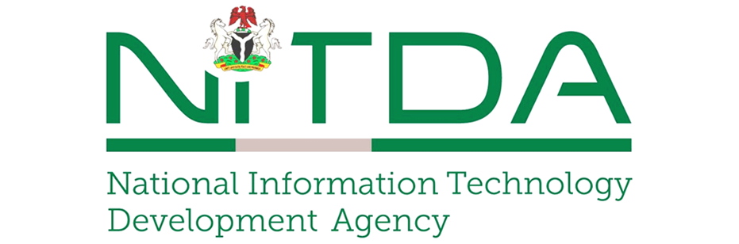

Keynote Address
By
Kashifu Inuwa Abdullahi, _{CCIE}
Director General/CEO,
National Information Technology Development Agency (NITDA)

At the

Nigeria Egovernment Summit

Theme:
Mainstreaming Technology in Nigeria Election Management

Thursday, 10th September 2026

Radisson Blue Hotel, Ikeja, Lagos State

Protocols…
Distinguished guests, ladies and gentlemen,
It is an honour to deliver this keynote at the 2026 Nigeria eGovernment Summit, themed “Mainstreaming Technologies in Nigeria Election Management.” This theme is timely, as Nigeria continues to explore how digital technologies can strengthen transparency, efficiency, and trust in our electoral process.
Over the years, Nigeria has made notable progress in deploying technology to strengthen its electoral process. A key innovation has been the introduction of the Bimodal Voter Accreditation System (BVAS) by the Independent National Electoral Commission (INEC) during the Isoko South Constituency I bye-election in Delta State on September 11, 2021and during the Anambra Governorship Election in 2021, where nearly 6,900 devices were used across polling units. BVAS authenticates voters using both fingerprint and facial recognition, which the INEC confirmed has effectively eliminated multiple voting and impersonation.
The Electoral Act 2022 further gave BVAS statutory legitimacy, transforming it into a legally protected electoral tool. In practice, BVAS has improved accreditation accuracy and transparency, with INEC reporting that over 99% of polling unit results were uploaded to the INEC Result Viewing (IReV) portal on Election Day in Anambra, allowing real-time public access. Civil society observers also noted its success in reducing impersonation during subsequent elections, such as the Osun Governorship Election in 2022, though they highlighted challenges like occasional device failures and connectivity issues in rural areas. Overall, BVAS represents a significant step forward in Nigeria’s electoral reforms, combining biometric verification with digital transparency to enhance credibility.
The introduction of BVAS has indeed reduced impersonation and improved voter accreditation. Yet, as our experience has shown, BVAS alone cannot fully address concerns about transparency in collation and auditing. This is where emerging technologies such as Blockchain and Artificial Intelligence (AI) can play a transformative role.
Blockchain delivers an immutable ledger—records that cannot be altered without immediate detection. Picture every polling unit result permanently secured on a distributed ledger, accessible in real time to INEC, political parties, observers, and citizens alike. Such radical transparency would shut the door on manipulation, making electoral fraud virtually impossible.
Artificial Intelligence on the other hand comes with a complimentary role in providing continuous, real-time auditing. With AI-driven anomaly detection, irregularities are flagged the moment they occur, ensuring that attempts at tampering are exposed instantly. Together, blockchain and AI form a formidable shield for democracy: one guarantees incorruptible records, the other ensures vigilant oversight.

At NITDA, our mandate is to drive Nigeria’s digital transformation, and we have already laid strong foundations that can support innovations in electoral management:
- NITDA coordinated the development of the Nigeria’s approved its first National Blockchain Policy on May 3, 2023, making it the first African country to adopt a nationwide blockchain framework. The policy aims to harness blockchain for transparency, efficiency, security, financial inclusion, and job creation, with implementation led by the Federal Ministry of Communications and Digital Economy (FMCIDE)
- We launched Nigeria’s National Digital Literacy Framework to achieve 95% digital literacy by 2030. This ensures citizens and officials can effectively use digital tools, including those deployed in elections.
- Through the Three Million Technical Talent (3MTT) and Digital Literact for All (DL4ALL) initiatives, NITDA is building a pool of skilled manpower in emerging technologies such as blockchain, AI, and cybersecurity—skills directly relevant to secure and transparent election systems.
- Nigeria Enterprise Architecture (NGEA) Framework (2022, and currently under-going review) provides structured digital governance models that can be adapted for electoral systems, ensuring interoperability and accountability.
- NITDA working closely with NDPC and ONSA, we have strengthened Nigeria’s data governance and cybersecurity frameworks, critical for protecting electoral data against manipulation.
These initiatives demonstrate that Nigeria is not starting from scratch. We already have the infrastructure, skills, and governance frameworks to mainstream advanced technologies into election management.
But let me emphasize: technology is not a silver bullet. Blockchain and AI can enhance credibility, but they cannot replace political will, institutional integrity, and civic responsibility. For Nigeria to truly mainstream technology in election management, we must combine innovation with accountability.
As we look ahead to future elections, let us commit to building systems that are not only digital but also democratic—systems that reflect the will of the people, protect their rights, and strengthen their trust in governance.
Together, we can set a new benchmark for electoral integrity in Africa, and NITDA stands ready to provide the digital leadership required to make this vision a reality.
Thank you.

